

**MEE 307**

**CAD/CAM PROJECT ON**

**HELICAL GEAR – DESIGN, ANALYSIS AND MANUFACTURE USING CNC**

**Team Members:**

Adarsh Modi – 10BME 1005

Yash Ganatra – 10BME1043

K Shrikanth – 10BME 1057

Vivek Varia – 10BME 1109

1. **ABSTRACT:**

This project aims at designing the gear using SOLIDWORKS CAD software and its machining using CNC TRAIN simulator. Gears are the most widely used transmission components. They find applications in the simplest of mechanisms to the high precision automatic gearboxes used in high end cars. Gear design is a multi-stage iterative process which starts with the selection of type of gear and ends when the appropriate dimensions are found so as to manufacture. Using Computer Numeric Control to machine a gear improves the surface finish and the accuracy.

1. **INTRODUCTION**

A Helical Gear has tooth in the form of helix wound around the gear. The pitch surfaces are cylindrical but the teeth wind around the cylinders helically. This provides continuous and gradual engagement of the teeth resulting in a smoother drive with a high transmission efficiency.

1. **LITERATURE REVIEW**

**3.1 KINEMATICS**

Helical gear can be thought of as an ordinary spur gear machined from a stack of thin shim stock, each limitation of which is rotated slightly with respect to its neighbours.



FIGURE 1: PARALLEL BETWEEN HELICAL AND SPUR GEARS

The shape of the tooth is an involute helicoid as illustrated in the Fig. 11.8. If a paper piece of the shape of a parallelogram is wrapped around a cylinder, the angular edge of the paper becomes the helix. If the paper is unwound, each point on the angular edge generates an involute curve. The surface got when every point on the edge generates an involute is called involute helicoid. In spur gear, the initial contact line extends all the way across the tooth face. The initial contact of helical gear teeth is point which changes into a line as the teeth come into more engagement.

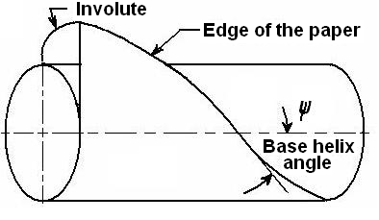

FIGURE 2: FORMATION OF HELICAL GEAR TOOTH

* 1. **FORCE ANALYSIS**



FIGURE 3: COMPONENTS OF FORCE

**Fr = Fn sin Øn………………. (1)**

**Ft = Fn cos Øn cos ψ………... (2)**

**Fa = Fn cos Øn sin ψ…………(3)**

**Fr = Ft tan Ø …………………(4)**

**Fa = Ft tan ψ …………………(5)**

1. **OBJECTIVES**

* The present study involves design and analysis of spur gear according to Lewis Bending Theory which states that at a given point of time maximum load acts on single tooth. The tooth acts as a cantilever beam.
* Validation of the theory is done by analysis on SOLIDWORKS and Von Mises Stress and displacement is found.
* CNC Code is generated using CNC Train Simulator. This is presented in the final review.

1. **PROBLEM SPECIFICATION**

* **Power Transmitted = 37.5 kW**
* **Transmission Ratio = 4.25**
* **Pinion rpm = 1750**
* **Material : ALLOY STEEL**
* **Helix Angle: 15˚**
* **Normal Pressure Angle: 20˚**
* **Normal Module : 3mm (Computed from theory)**
* **Load on a tooth = 10 383 N (calculated from eqn 2)**
* **Yield Strength = 620 MPa**

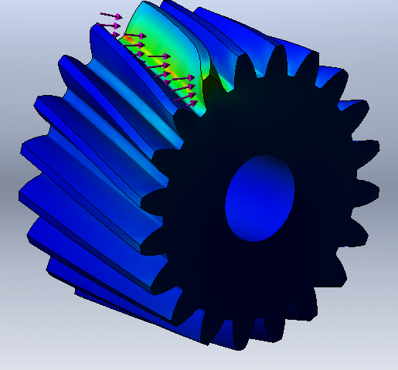

FIGURE 4: LOAD DIRECTION

1. **SIMULATION RESULTS**

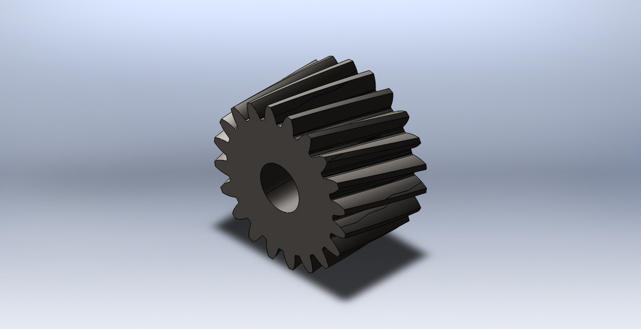

FIGURE 5 : HELICAL GEAR MODEL

**Mesh Details:**

|  |  |
| --- | --- |
| Mesh type | Solid Mesh |
| Mesher Used: | Standard mesh |
| Automatic Transition: | Off |
| Include Mesh Auto Loops: | Off |
| Jacobian points | 4 Points |
| Element Size | 4.83026 mm |
| Tolerance | 0.241513 mm |
| Mesh Quality | High |
| Total Nodes | 24751 |
| Total Elements | 15568 |
| Maximum Aspect Ratio | 17.786 |

TABLE 1: MESH DETAILS

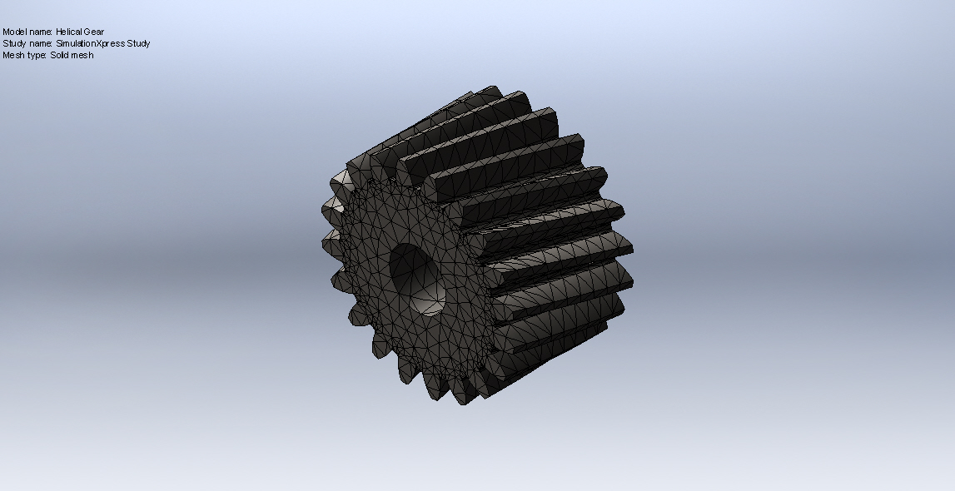

FIGURE 6: MESHED STRUCTURE

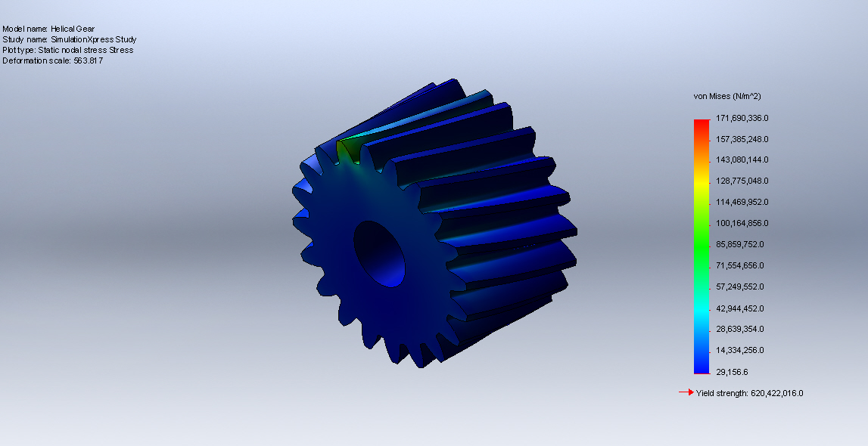

FIGURE 7: VON MISES STRESS

The maximum Von Mises Stress is 172 MPa which is less than the yield strength.

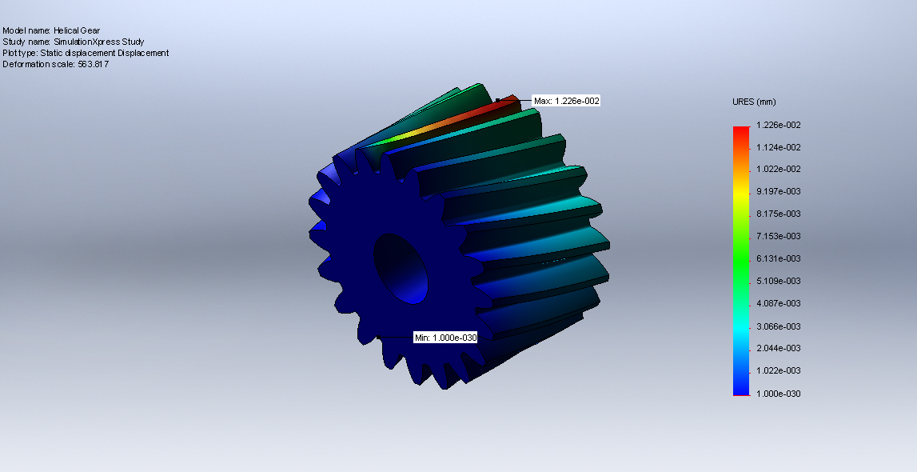

FIGURE 8: RESULTANT DISPLACEMENT

The maximum displacement is 1.3 e-2 mm.

1. **CNC CODE FOR SPUR GEAR GENERATION**



Figure 9: SPUR GEAR BLANK DIMENSIONS



Figure 10: Process Sheet for First Operation



Figure 11: Process Sheet for First Operation









Figure 12: Blank after Rough Turning





Figure 13: Finishing Cycle



1. **VALIDATION OF RESULTS**

The Gear Design Principles learnt in Design of Transmission Systems have been applied. PSG Design Data Book has been used as the reference.

**MATERIAL PROPERTIES:**

* Ϭy = 88 Kgf/mm2
* Ϭy = 1760 N/mm2

**ALLOWABLE BENDING STRESS:**

[Ϭb]=

* n =2.5
* Kb1 =0.7
* KϬ = 1.5
* Ϭ-1 = (0.35u) + (1200) = 7360 Kgf / cm2
* [Ϭb] = 192.341 N/mm2

**ALLOWABLE COMPRESSIVE STRESS:**

* [Ϭc] = CR*HRC*Kc1 = 852.6 N/mm2
* CR = 265
* Kc1 = 0.585
* [Ϭc] = 852.6 N/mm2

**CENTRE DISTANCE:**

* a ≥ (i+1)
* [Mt] = Mt*K*Kd
* K*Kd =1.3
* Mt = 2087.57 N-mm
* Ex  = 207 * 109 Pa
* = 0.5 (assumed)
* ≥ 154.44 = 155 mm
* Z1 = 20
* Z2 = 85
* Mn = = 2.85 = 3 mm
* Revised centre to centre distance:

a = = 163.055 mm

d1 = = 62.164 mm

d2 = = 263.995 mm

**REVISED TWISTING MOMENT:**

* b = Ψ*a = 81.5275 mm
* Ψp = = 1.3124
* K = 1.165
* V = = 5.6917 m/s
* Kd = 1.2
* [Mt] = Mt*K*Kd = 3066.77 * 102 N-mm

**INDUCED BENDING STRESS:**

* Ϭb = 0.7*) = 70.25 Mpa < [Ϭb]
* Zv = = 22.192
* Form Factor (Yv) = 0.402

**INDUCED BENDING STRESS:**

Ϭc = 0.7**

Ϭc = 698.7 Mpa < [Ϭc]

1. **ACKNOWLEDGEMENTS**

We would like to thank our subject faculty Prof R. Jegadeeshwaran for his help and support during the project and Prof. Davidson for his help during the analysis and validation stage.

1. **REFERENCES**

* Khurmi R.S., Design of Machine Elements, S.Chand Publications,2012
* Shighley Joseph, Mechanical Engineering Design, Mcgraw Hill Publications, 2012
* Solidworks Manual - 2012